Assignment 4

Sri Sai P
​​Advance Artificial Intelligence
MSCS-633-M50

Screenshot of my experiment output
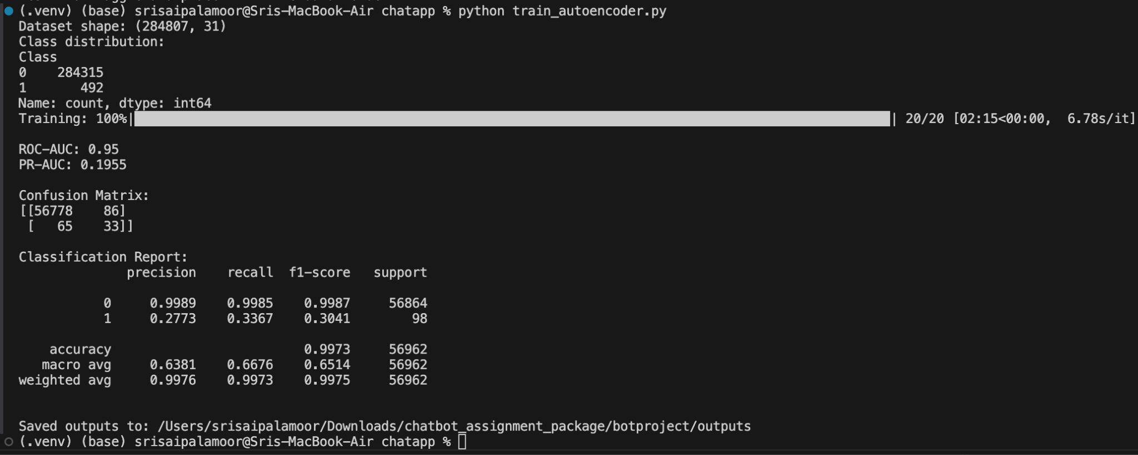

Github Link:
https://github.com/spalamoor39148/MSCS-633-M50-Assignment4

